Wholesale Watermelon Seed Kernels: Premium Quality, Factory-Direct Supply for Global B2B Buyers
Xinjiang GOODLUCK Import & Export Co., Ltd. is a leading exporter of premium bulk watermelon seed kernels (hulled, natural, unseasoned) from China’s Xinjiang Uygur Autonomous Region—renowned for its arid climate, fertile soil, and strict quality control that delivers world-class nutraceutical and culinary ingredients. With 10+ years of export experience, we specialize in supplying B2B buyers across Europe, the Middle East, North America, and Southeast Asia with consistent, traceable, and food-safe watermelon seed kernels, tailored for snack manufacturing, bakery, health supplements, and functional food production.

Our core advantage lies in direct farm-to-factory integration: we source exclusively from Xinjiang’s certified planting bases (annual cultivation area >80,000 mu/13,200 acres), process seeds with automated dehulling and optical sorting lines, and maintain full traceability from harvest to export. We ship 20,000+ metric tons annually to global buyers, with a 98.5% customer retention rate—proven by verified trade data and repeat orders from top food manufacturers and distributors.

Core Product Specifications | Unseasoned Hulled Watermelon Seed Kernels
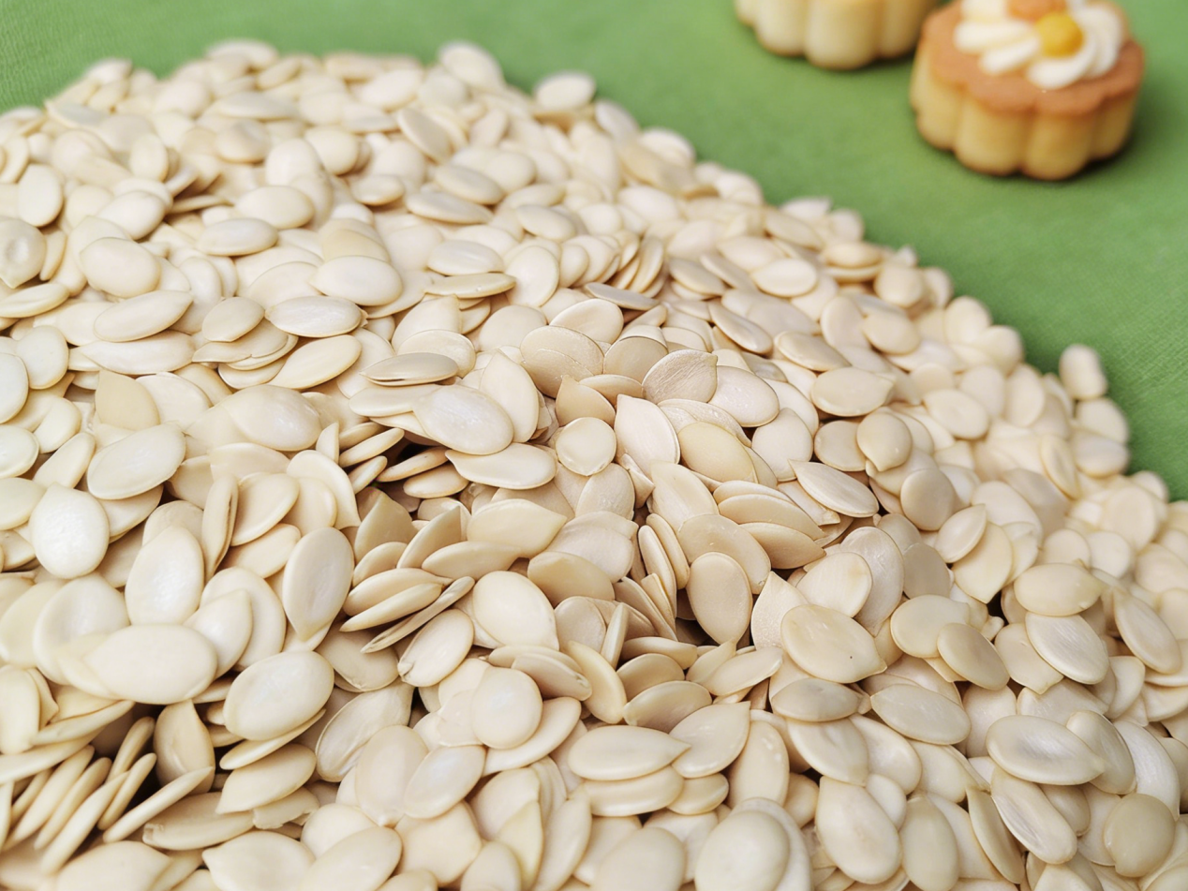
Parameter | Standard Specification | Test Method | Compliance
Purity | ≥99.5% | Visual Inspection + Sieve Analysis | HACCP
Moisture | ≤6.0% | Oven Drying (105°C, 2h) | BRC
Impurity | ≤0.1% | Gravity Separation | HACCP
Kernel Size | 8–10 mm (uniform) | Digital Caliper Measurement | Customizable (7–11 mm)
Color | Creamy White / Pale Yellow | Visual Grading | BRCGS Issue 8
Fat Content | 26–28% | Soxhlet Extraction | GB 5009.6
Protein Content | 17–19% (dry basis) | Kjeldahl Method | GB 5009.5
Total Ash | 2.5–3.0% | Muffle Furnace (550°C) | GB 5009.4
Heavy Metals | Lead ≤1.0 ppm; Arsenic ≤1.0 ppm; Cadmium ≤0.5 ppm | ICP-MS | SGS
Microbiology | Total Plate Count ≤10,000 CFU/g; Yeast/Mold ≤30 CFU/g; Salmonella/ E. coli Negative | AOAC Official Methods | EU Regulation (EC) 1881/2006
Aflatoxin B1 | ≤2 ppb | HPLC | GB 2761
Non-GMO | 100% Certified | PCR Testing | HALAL

Xinjiang GOODLUCK Import & Export Co., Ltd. is a leading exporter of premium bulk watermelon seed kernels (hulled, natural, unseasoned) from China’s Xinjiang Uygur Autonomous Region—renowned for its arid climate, fertile soil, and strict quality control that delivers world-class nutraceutical and culinary ingredients. With 10+ years of export experience, we specialize in supplying B2B buyers across Europe, the Middle East, North America, and Southeast Asia with consistent, traceable, and food-safe watermelon seed kernels, tailored for snack manufacturing, bakery, health supplements, and functional food production.

